Governor Stirling Senior High School
Year 12 Physics
Task 1: Projectile Motion Investigation

NAME: _________________________

TEACHER:______________________

MARKS: /30

Instructions:

- Do not turn this paper over until you are told to do so

- Answer all the questions in the spaces provided

- All questions do not carry equal numbers of marks

- Marks available for each question are shown

6. Use the appropriate number of significant figures for estimations

7. An approved scientific calculator may be used

8. Write with a blue or black ink pen. You may use a lead pencil to draw diagrams.

Formulas which may be of use:

v = s/t F = ma

v = u + at

v² = u² + 2as

s = ut + ½ at²
INVESTIGATION 30 marks

AIM: To use the photographs taken to investigate the effect of resistance on the motion of a test object undergoing projectile motion.

Clearly show how you have made your measurements from the photos and show your calculations in detail.

Note: Mass of toy missile = 5.842 g Distance between lines on scale: 10cm (0.10m) Strobe setting: 10 Hz (0.1 sec between flashes.)

PHOTO: (Some lines have been drawn to help with your measurements).
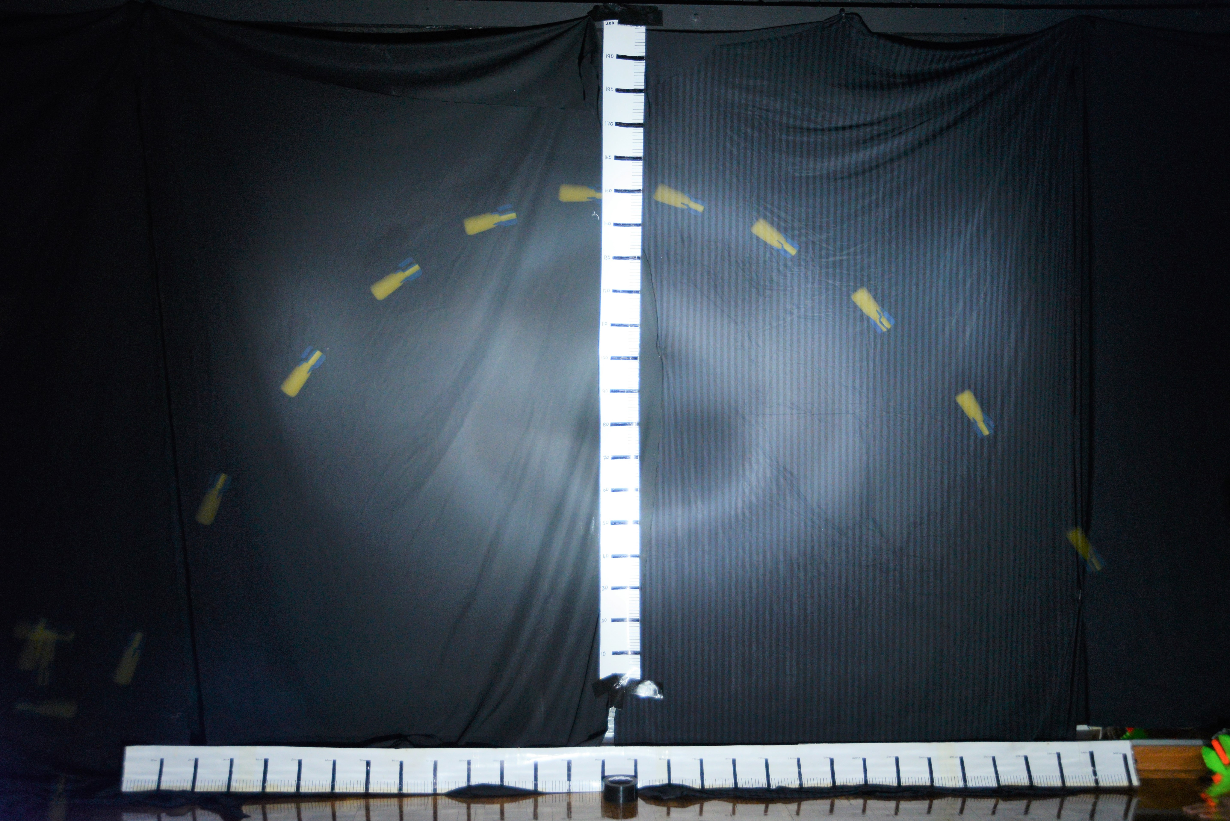

First image

Last image

START
FINISH

Total flight time = _____________ Total horiz. displacement = ________________

(2 marks)

- Determine the initial horizontal velocity of the projectile. Use the first two images. (Lines have been drawn from the top of the first projectile image). (1 mark)
u_{h} = s/t = ______ / ________ = ___________

- Measure the take-off angle: _____________ degrees. (1 mark)

- Using this value and your answer from questions 1.0 and 3.0, calculate the initial total take-off velocity (u) and hence calculate the initial vertical velocity (u_{v}). (2 marks)

u_{h} = ucosӨ so u = U_{h}/cosӨ = ____________________________________________

u_{v} = usinӨ = _____________________________________________________________

- From your answers to questions 1.0 and 2.0, determine the theoretical range and maximum height of the projectile. (4 marks)

Theoretical range = u_{h} x t_{tot} = ______________________________________

Theoretical vertical height:

- Using your answers to 4.0, sketch the theoretical curve on top of the photograph. (2 marks)

- From the photograph, determine the final horizontal velocity of the projectile.
(Use the last two images on the left). (1 mark)

- Using u_{h} and your answer from 6.0, calculate the change in horizontal velocity and hence the average horizontal deceleration over the total time of the flight
(2 marks)

- Using your answer to 7.0, calculate the retarding horizontal force on the projectile. Express your answer to the appropriate number of significant figures. (4 marks)

- From the graph, estimate the “final” vertical velocity of the projectile (use the last two images on the left).
(1 mark)

- Using the initial vertical velocity as zero, your answer from 9.0 and the displacement from the highest point to the last image, calculate the downward acceleration on the projectile while it is falling.
(2 marks)

- Knowing that the downward acceleration should be 9.8 ms⁻², from your answer to 10.0, calculate the upward force on the projectile due to air friction
Express your answer to the appropriate number of significant figures (4 marks)

- Using the photo below, determine Ikram’s average speed. (4 marks)

Show on the photo from where you have taken your measurements.
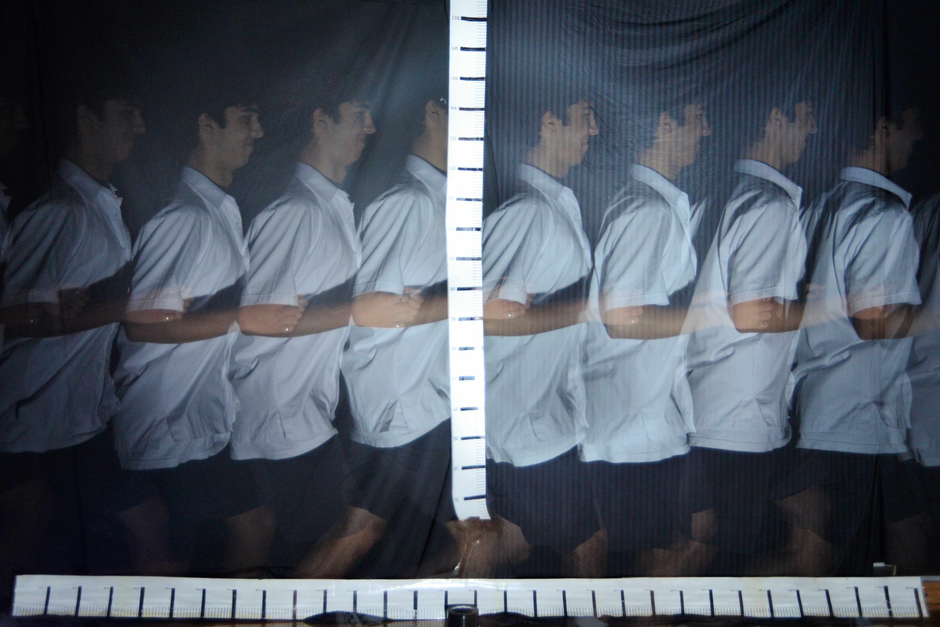

S= ________________ t = _________________ V = ___________________

